#1 Which API Provides Market news? Why is it empty?
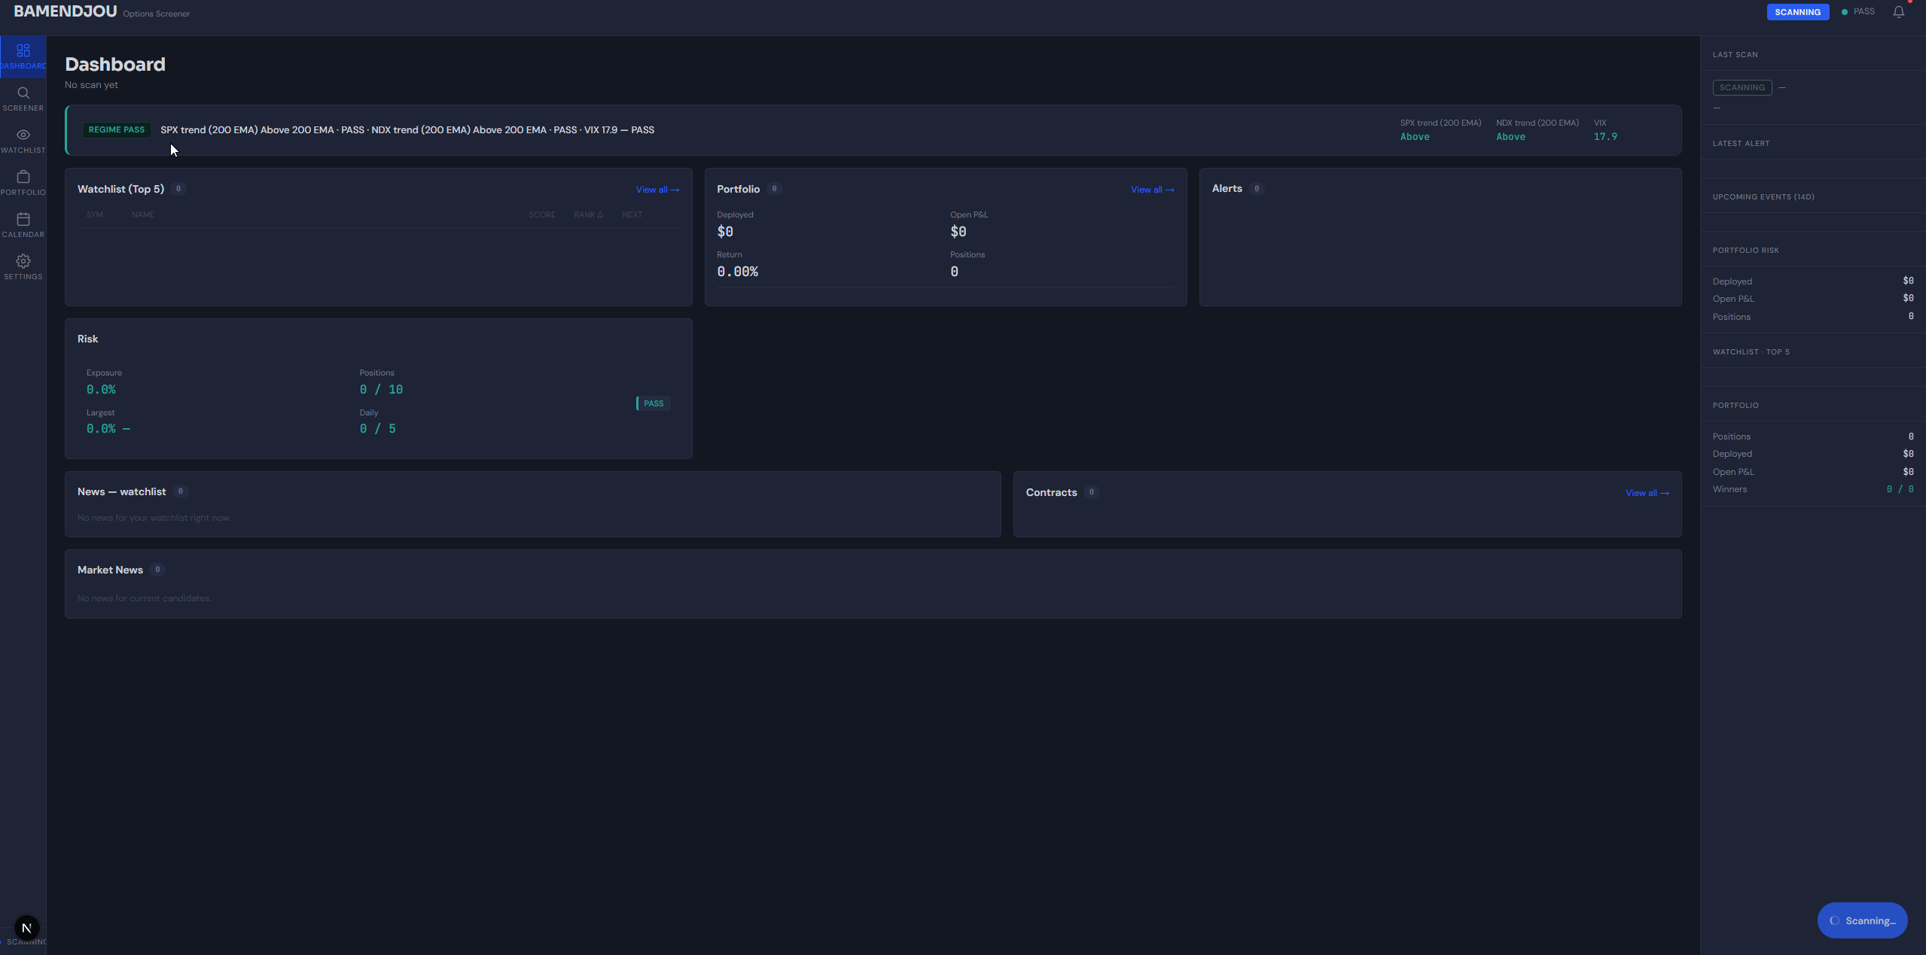
What happens if I select Custom list an enter no symbol and hit scan?
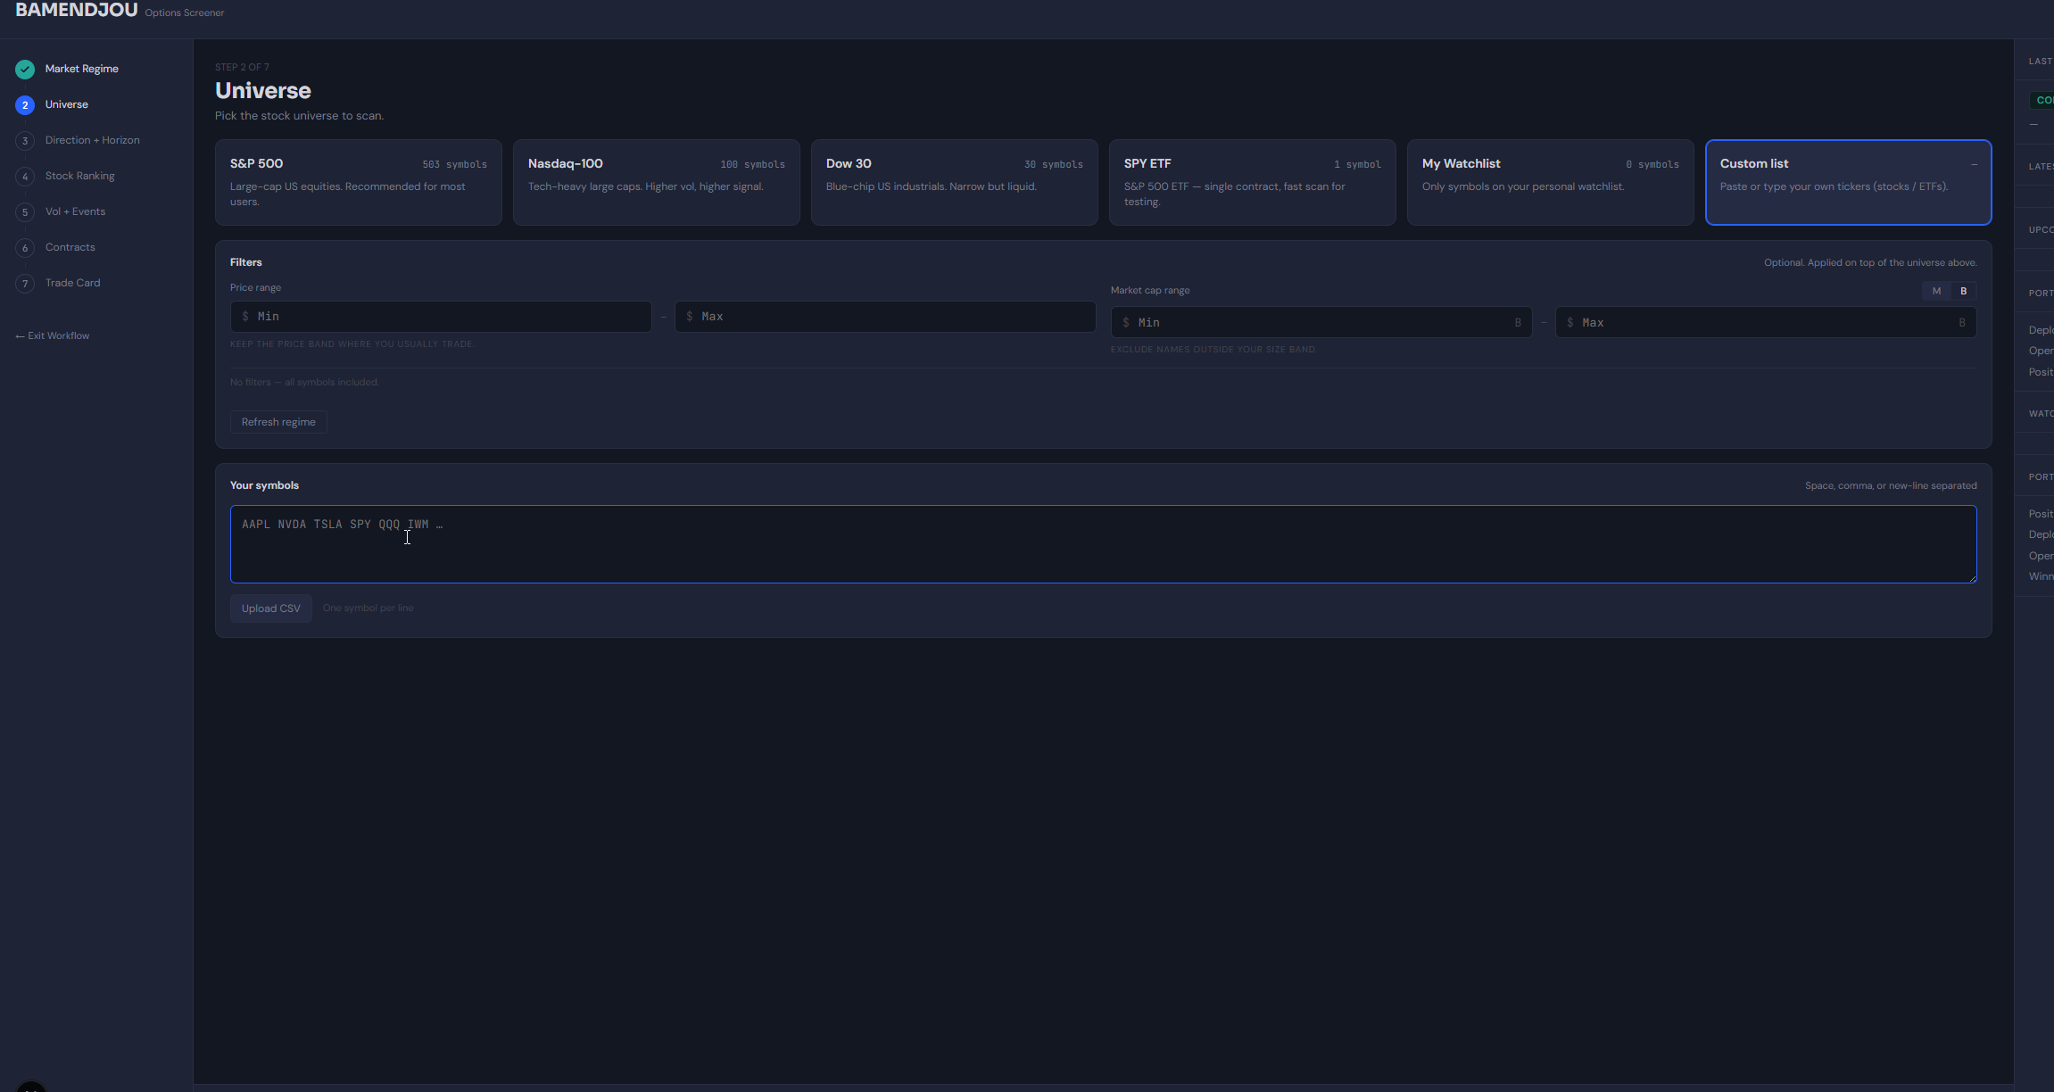
#2 Direction+ Horizon.
- Rejection breakdown and and the sore are too far from each other bring the numbers neared to the rejection reason and use a tabular form
- Give the rejection reason breakdown (trend/ Pullback/ trigger etc)
Eg. 519 Rejection. 200 -trend reject / 150 pullback reject etc look at the screenshot bellow
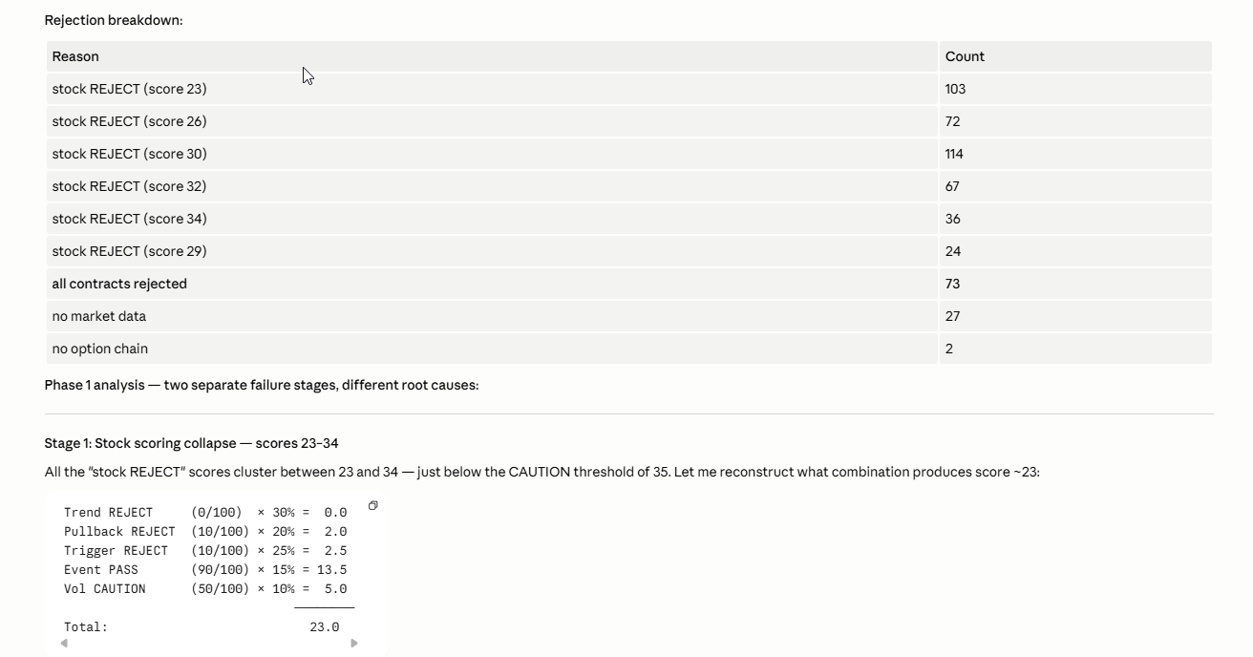
In den logs Also Display as information how the wight are distributed for the execution
Show also in the logs the detail for scoring rejection of the contracts
Execution Parameter
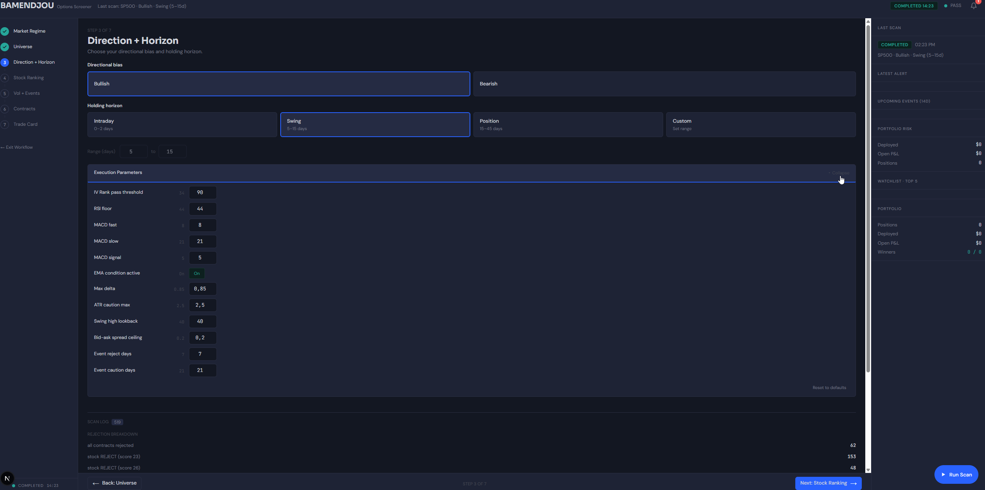
Explain the EMA condition active. Expectation is that I Can choose between EMA50>EMA200 and SMA50>SMA200 for example. To either be fast or slow. Display what condition is considered .its a different value based on the horizon

How to read the notifications? I see the bell and a red dot but i cannot read anything
Do the execution logs of previous seeions get stored some where?
I got an Error Yesterday when i was moving from contract to trading card. I got an Error. I canot reproduce now because i find stock . Debug deeply and let me know find an error.
Confirm that the configurations in settings are considered. Is there any Overlap with the execution parameters in directions+ horizon?
